Regional Roster Report

All regional Presidents and Secretaries have access through the SGNA Portal to pull full membership reports for their region. Membership lists are updated in real time with each member’s contact information. This report can be used for various outreach activities and marketing throughout the year. Please be sure to review the guidelines and best practices document in full, to learn more about downloading reports, updating chapter leaders, and additional features.

Downloading Roster Report:

- Login to SGNA account
- Go to SGNA Portal
- Click on account icon at the top right of the page, and select Chapter Leader Tasks
  - If you do not see this option and are a current regional president, please contact info@sgna.org.

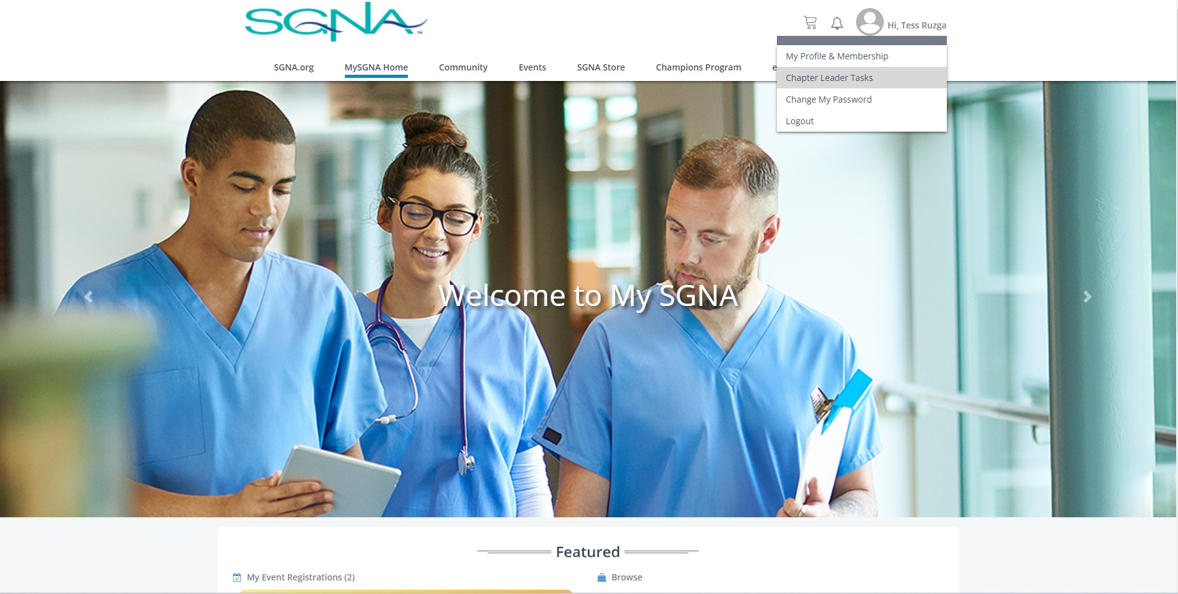

- Select your region

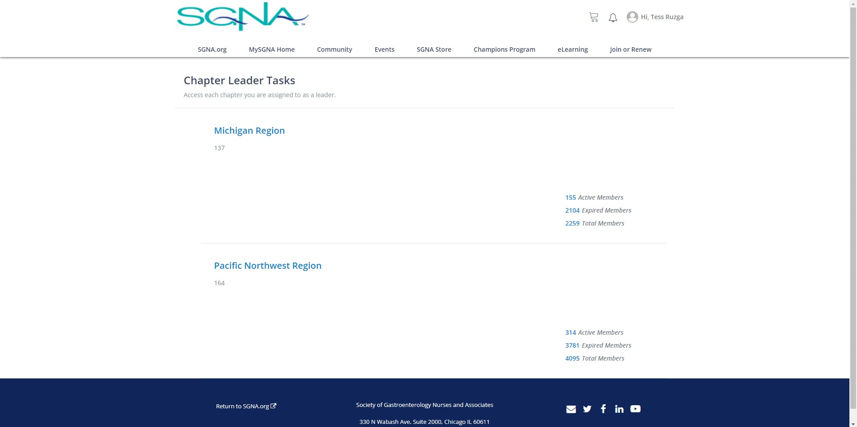

- Select Download Roster

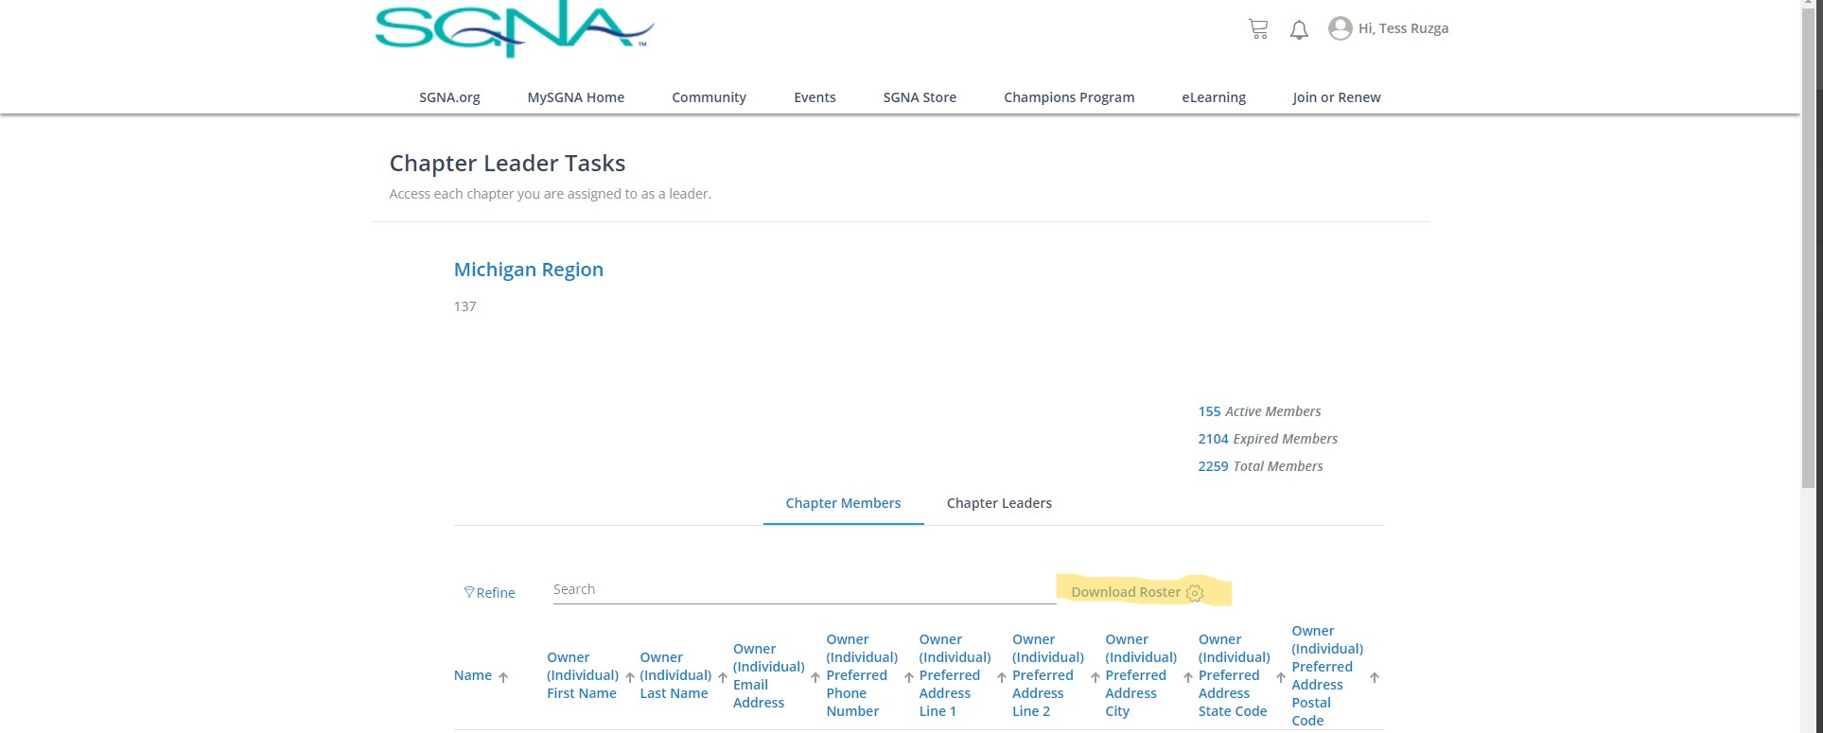

- An excel file with your member list should then download to your computer
- If you would like any additional information added to your region roster, please contact info@sgna.org.

Chapter Leaders:

If you would like to update who has access to roster reports, you can add or delete individuals from the chapter leader list.

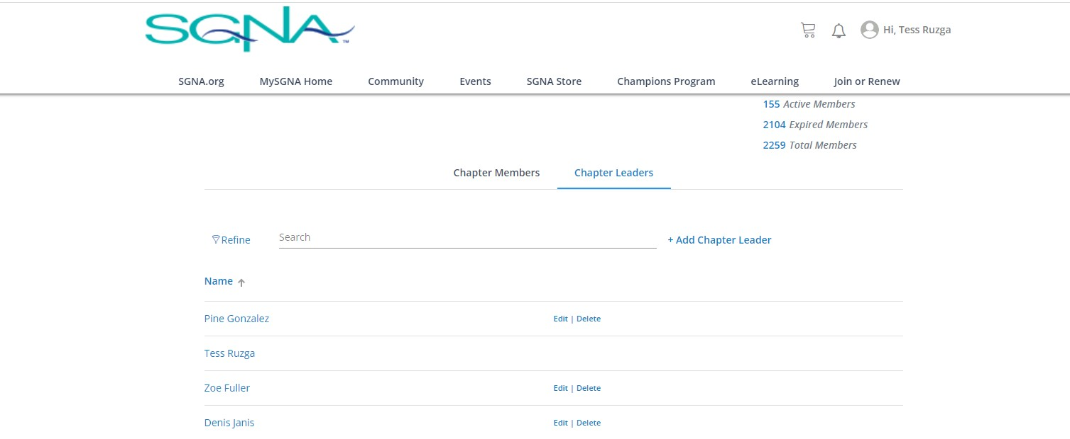

Additional Features:

Chapter Leaders also have the ability to send emails through the SGNA Portal. The email feature allows Chapter Leaders to easily send communications via email to current and lapsed members.

- Under Chapter Leader Tasks select Email Members
- Refine search by All Members, Active Members, and Past Members, based on your desired message

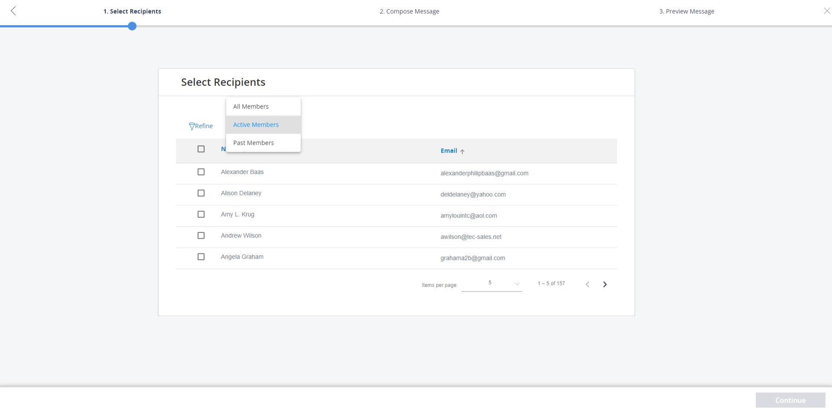

- Once you’ve selected the recipients you can then compose your message
- Choose the email address you would like to use and the contents of your email

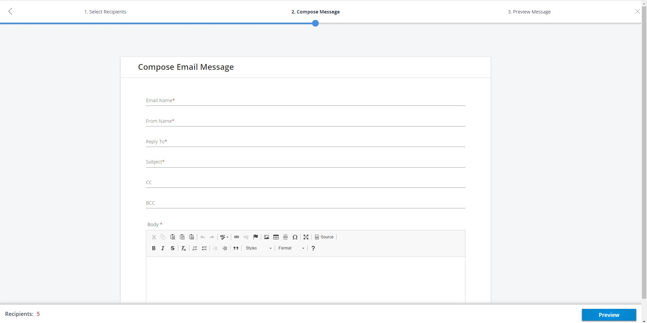

- Review Message and send!

If you have any questions regarding this feature, please reach out to info@sgna.org.

