Accessing your Membership Rosters

Below are step by step instructions on how you can access your regional roster:

- Sign into your SGNA account

- Under the My SGNA tab on the left hand side of the webpage, click Regional Roster Reports as you see highlighted in the image below:
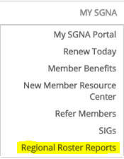

- In the next window, select your region and click Submit

- A new window will open showing your regional roster. There are a number of functions on this page- export list, print list, and create address labels. You also have the ability to see which members have expired memberships and need to renew in order to continue receiving member benefits. View the image below:
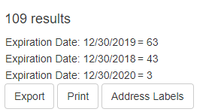

- Click the corresponding button to the action you want to complete

